Handbook for Scout Group Leaders and National/International Coordinators

Litter Less Campaign Phase V
Young Reporters for the Environment

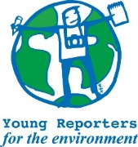
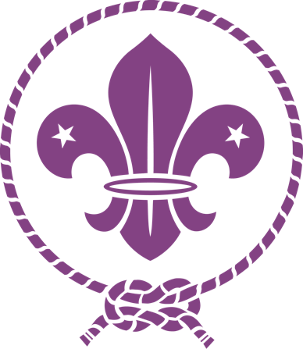
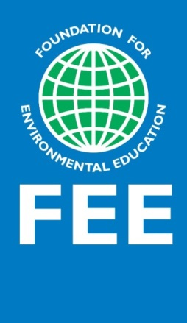
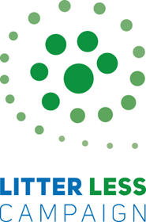

YRE Litter Less Campaign

Handbook 2023
This Handbook is for Adult Scouts leaders to help you implement the Litter Less Campaign, as part of your Youth Programme offer. If your NSO has already adopted Earth Tribe you can integrate in into the path and learning objectives associated with the path of Better Choices or integrate it as part of your environmental education component. You can copy pieces of the Handbook and adapt it to materials you produce for scouting activities in your country.
January 2023, Foundation for Environmental Education

Contents
Handbook for Scout Group Leaders and National/International Coordinators 1
Litter Less Campaign Phase V 1
YRE Litter Less Campaign 2
Handbook 2023 2
1. BACKGROUND 4
1.1 Overview of partnership with the Mars Wrigley Company Foundation, FEE and WOSM 4
1.2. Participating countries 4
2. WHAT IS THE LITTER LESS CAMPAIGN? 5
2.1 Introduction 5
Scouts, individually and as a group, will: 5
2.2 Why litter and waste? 5
2.3 Goals 6
The campaign’s main objectives are: 6
2.4 Litter Less Campaign and Earth Tribe Initiative 6
2.5. Sponsor – The Mars Wrigley Foundation 8
2.6 About Young Reporters for the Environment 9
2.7 Educational materials 9
3. IMPLEMENTATION PLAN 11
3.1 Information Workshop for group leaders 12
3.2 National and international competitions 12
3.3 Pollution campaign 12
Litter Less Plus – A 1-year awareness-raising campaign about pollution 13
3.4 Time frame 14
4. IMPACT MEASUREMENT 15
4.1 Description of Impact Measurement 15
4.2 Impact measurement survey 15
4.3 Capturing the impact of Scouting for SDGs 15
5. TECHNICAL INFORMATION FOR NATIONAL OPERATORS 17
5.1 Reporting, evaluation and future 17
6. WEBSITE AND SOCIAL MEDIA 18
6.1 Planned external communication/media outreach related to this grant and program 18
6.2 Reporting from Scouts International Coordinator at WOSM 18
6.3 Litter Less logo 19
6.4 Earth Tribe Initiative Logo 19
7. Annexes 20
Annex 1: Additional information Young Reporters for the Environment 20
Annex 3: Participating numbers for 2022 20
Annex 4: Campaign implementation cases from previous years 21
Stories from Countries — Young Reporters for the Environment (yre.global) 21
Annex 5: Four YRE steps to implement the campaign 21
1. Investigation 21
2. Proposing solutions 21
3. Reporting 21
4. Informing 22

1. BACKGROUND

1.1 Overview of partnership with the Mars Wrigley Company Foundation, FEE and WOSM
The Litter Less Campaign is a joint project between Mars Wrigley Foundation and Foundation for Environmental Education (FEE). Running for 11 consecutive years (Phase I, II, III and IV) all around the globe, it underlines tangibly the importance of dealing with the issue of litter and waste to minimize its negative impact on the environment.
With steadily increasing popularity, the Campaign has engaged, since its implementation in 2011, more than 4,8 million students from 38 countries. Through continuous evaluation, the increase in the student’s litter and waste literacy as well as their lifelong skills and eagerness to learn have been documented.
The World Organisation of Scout Movement (WOSM) was invited to join the Litter Less campaign in 2022 to increase the impact of the campaign through informal education. As front runners promoting sustainability through community engagement and active citizenship in informal education, Scouts will contribute greatly to the campaign’s goals.

1.2. Participating countries
Scout groups from the following countries are invited to participate in the campaign that will be coordinated on a national scale through the YRE National Operator (NO; A representative from a FEE member organisation implementing the YRE programme). The campaign is coordinated internationally from the FEE Head Office in Copenhagen. List of NOs running the YRE countries is available here National Offices — Young Reporters for the Environment (yre.global)
YRE and Scouts: Argentina, Greece, Portugal, Malaysia, South Africa and India

2. WHAT IS THE LITTER LESS CAMPAIGN?

2.1 Introduction
The Litter Less Campaign aims to empower young people, to find solutions to litter and waste issues they face, by providing them with the necessary knowledge, attitude and skills to change their environment and affect others to do the same.
How does it work?
Scouts (ages 11-25 years) participating in the Litter Less Campaign will act as Young Reporters for the Environment and produce journalistic pieces in the form of articles, videos, or photos that promote solutions for local litter and waste challenges. Scouts will disseminate their work to local media and will also be able to submit their work to a national YRE-LLC competition. The winning entries in the national competition will be further submitted to the international YRE competition. Winners in both competitions win prizes and receive national and international exposure and recognition. Furthermore, scouts will organise action days and develop action plans to tackle local waste problems.

Scouts, individually and as a group, will:
- Investigate and report on litter and waste issues and propose solutions to these issues
- Scouts leaders will closely collaborate with the YRE coordinators on the national level
- Participate in relevant training organised by YRE coordinators
- Work as a team and act as leaders for the whole community (e.g. motivate other scouts to implement the proposed solution(s)))
- Organise Community Action Days and participate in activities related to the LLC and Litter Less Plus (see information on LLP below) during the year
- Educate yourself through FEE Academy courses about environmental journalism FEE Academy — Foundation for Environmental Education
- Promote LLC and LLP activities taken by groups through media channels using #litterlesscampaign
- Submit articles, photos or videos for the YRE competition to the national coordinator of the YRE programme
A vast range of tools and educational materials (point 2.6) will be available for scouts during the campaign, e.g. a variety of actions aiming to convey knowledge on the environmental consequences of litter and waste as well as planning actions to improve waste management and reduce littering.

2.2 Why litter and waste?
Litter is a great place to start working on environmental issues with youth. It is visible and it is easy to see the improvements in the environment after it is picked up. One can identify litter in many ways. In this campaign, litter is defined as follows:
‘Litter is waste in the wrong place’
Irrespective of its form and if it is intentionally or unintentionally generated, litter’s negative consequences are numerous: litter can be harmful to people, animals, and the natural environment, as it can threaten their existence and evolution and disrupt naturally occurring cycles of elements. The major impacts involve the threat to public health, the risk of fire hazards, threatening, or even killing wildlife, and serious harm to waterways. Furthermore, litter, directly and indirectly, affects the tourist industry and quality of life; because of this irresponsible pollution, protecting the environment from litter requires more spending, which could have been used in environmental preservation or development instead.

2.3 Goals
Through the campaign, Scouts will be empowered to understand the key litter and waste issues in their communities and drive awareness-raising campaigns that focus on various aspects of circular economy, such as responsible consumption, re-use and recycling but also on the negative impacts of waste, thereby promoting long-term behaviour change as well as a cleaner environment.

The campaign’s main objectives are:
- To reduce the litter and waste footprint of communities by strengthening scouts’ litter and waste literacy
- To increase scouts’ knowledge and practical skills in preventing and managing litter and waste, thereby promoting the Circular Economy concept and fostering long-term behaviour change
- To improve the waste management in scout groups facilities and/or nearby surroundings
- To educate youth as opinion leaders and active citizens so they can find solutions to litter and waste issues, disseminate them through social media and other channels and catalyze a change in their communities
- To collaborate with other scout groups nationally or internationally to disseminate good examples, encourage them to take action and increase the positive impact

2.4 Litter Less Campaign and Earth Tribe Initiative
In the context of the Earth Tribe Initiative, you can link the Litter Less campaign and activities in the path of better choices aiming to develop habits towards eco-friendly and healthy lifestyles, motivating young people to be Advocates for Better Choices while they become Youth Reporters of Environment.

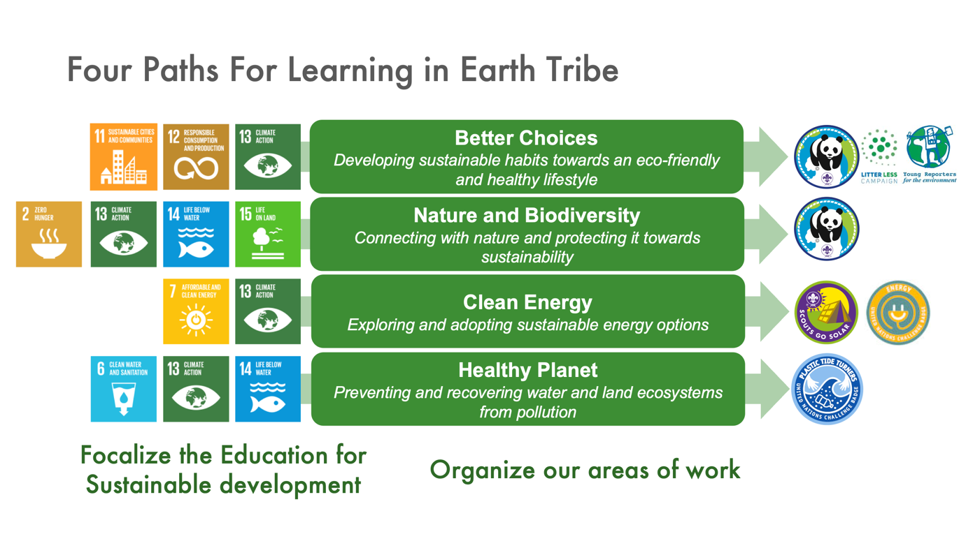

Better Choices is one of the 4 complementary paths to become part of the Earth Tribe community.
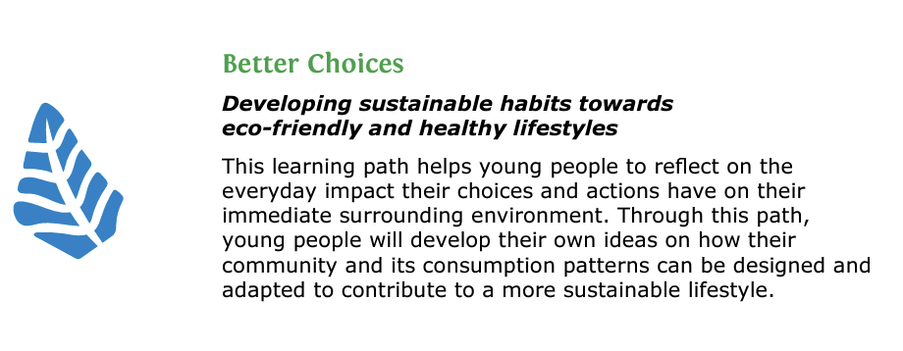

Advocates for Better Choices are young people who become voices to protect our planet by modifying our consumption habits and the way we do things every day in our life.
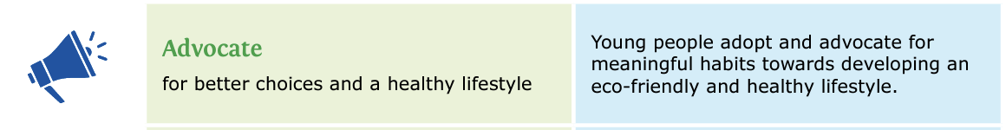

Recognizing the efforts of young people
In addition to the elements presented by LLC, you can introduce young people to Earth Tribe and invite young people to:
- Go through the YRE activites as a learning and awareness experience
- Support young people to think and design a community development project
- Evaluate their journey through Scout Method and personal progression and the Earth Tribe Challenge journey (page 14 Earth Tribe Implementation Manual)
- Match their achievements with some form of recognition element:
  - An existing badge in your NSO youth programme
  - A temporary toke like pin, badge or other relate to LLC
  - A certificate for their efforts.
- Organize a simple but significant ceremony
- Present the Earth Tribe Pin

Using Earth Tribe and SDGs learning objectives
You can use the Better Choices learning objectives as a way to evaluate personal development and behavioural change while young people explore the YRE and LLC journey. (Page 18 Earth Tribe Implementation Manual)
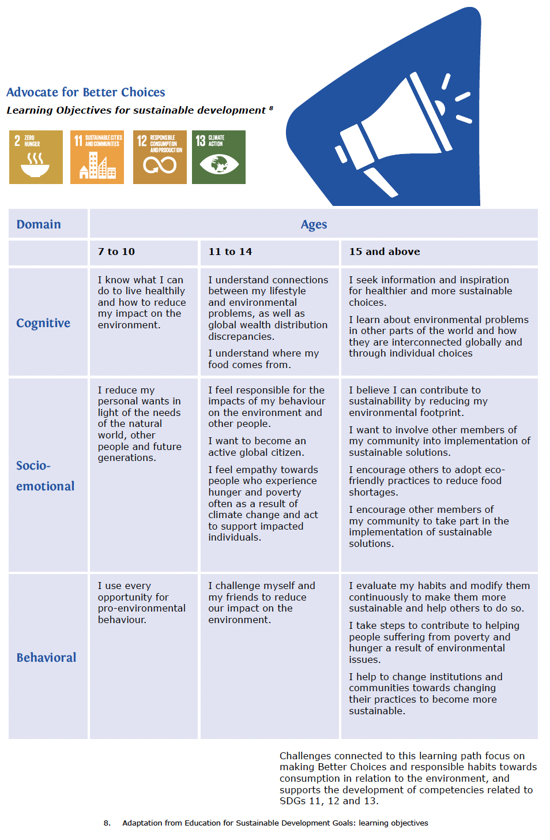

2.5. Sponsor – The Mars Wrigley Foundation
The Mars Wrigley Foundation partners with organisations around the world to help people and communities become more sustainable. Since its establishment in 1987, the Mars Wrigley Foundation has contributed over 100 million USD to projects that support oral health education and care, improve lives in mint- and cocoa-growing regions, prevent litter and waste and create vibrant communities. Through the King Baudouin Foundation U.S., the Mars Wrigley Foundation has provided support for a three-year Litter Less Campaign to be run by the Foundation for Environmental Education from 2022-24.

2.6 About Young Reporters for the Environment
Young Reporters for the Environment (YRE) is a network of international youth engaged in education for sustainable development. Its goal is to empower young people to take an informed stand on environmental issues, investigate them, research solutions, report and disseminate this work through journalistic pieces, thus enabling its participants to develop precious skills and expand their knowledge. In the context of the Litter Less Campaign, the YRE network acts as the driving force to report on litter and waste issues (https://www.yre.global/).
For additional information regarding YRE, please refer to Annex 1.

2.7 Educational materials
Activity Plans for scout leaders will be available on Podio and the YRE website (Litter & Waste Lesson Plans — Young Reporters for the Environment (yre.global) and the LLC website YRE — Foundation for Environmental Education (fee.global), in English. The Activity Plans include hands-on practical and inquiry-based learning for scouts. Here are some examples of actions suggested for scouts Materials for Scouts — Young Reporters for the Environment (yre.global).
The Activity Plans cover most aspects of the Circular Economy Concept (I.e. reduced waste generation and optimisation of resource use through responsible consumption and effective waste management). It is therefore strongly recommended for scouts to use the Activity Plans as a basis for the campaign or at least align their educational resources and activities with some of those mentioned in the Activity Plans.
In addition, we recommend you complete the FEE Academy courses on Pollution and Circular Economy. These courses are available in various languages and will provide you with an overview of the topics.
- Pollution course in English, Portuguese, Swahili, French and Spanish. This course aims to provide you with an overview of different types of pollution and their sources. The course also describes some of the main environmental and health impacts of pollution and presents you with success stories and best practice examples on how pollution can be prevented

- Circular Economy course (Only in English) will provide you with an overview of the principles for shifting a linear economy to a circular one.
We also recommend you use the UNESCO Trash Hack Campaign educational resources, as an inspiration for your Litter Less Campaign scouting activities. These are available on the YRE website: https://www.yre.global/trash-hack-campaign-about
Other educational materials for the Litter theme are available on Podio in Files Library. These materials include also:
- Logos of the LLC and sponsors and partners
- Flyers/Brochure
- Handbooks for Scouts group leaders and national/international coordinator
- Guides and manuals
- Scripts and tutorials
If you require translations, please check with us if it is possible to provide them.

3. IMPLEMENTATION PLAN
The following steps can help with the implementation of the Litter Less Campaign:
Scouts national coordinator:
- Recruit and select scouts groups to participate in the campaign
- Make sure that the participating groups and organisations have all necessary information + provide necessary information on your website and educational resources from FEE and WOSM (incl. Earth Tribe). This can be done through a workshop as described in Point 3.1.
- Provide contact details of participating scout groups and organisations to the YRE National Operator so FEE can track the reach of the campaign and assist if necessary (The contact details of the YRE National Operators can be found in Annex 2)
- Invite scouts to participate in the following activities as part of the LLP (More information on the LLP is below):
- Pollution Quiz
- Global Action days on Pollution
- Educational Grant for Circular Economy Projects
- Sharing of best practices
- Suggest scout groups to participate in the workshops & webinars organized by either FEE International or the involved YRE National Operator
- Invite scouts to follow the journalistic courses on FEE Academy - FEE Academy — Foundation for Environmental Education (especially journalistic courses and the pollution course)
- Make sure the scouts' groups participate in the YRE competition (the new round will be announced in September 2023, submissions will be in March-April 2024 to the National Operators in each YRE country)
- Engage with and provide ongoing support for the scouts' organisations
- Monitor and collect data about the participants using surveys and focus group interviews with selected group leaders upon request from FEE and WOSM

Scout group leaders
- Make sure you are acquainted with the campaign’s goals, resources, activities and expected outcomes provided by your national scout coordinator and/or YRE National Operator
- Engage your scout group in the campaign’s activities as part of the LLC Plus:
- Pollution Quiz
- Global Action days on Pollution
- Educational Grant for Circular Economy Projects
- Sharing of best practices
- Suggest your scouts participate in the workshops & webinars organized by either FEE International or by the involved YRE National Operator (See table below).
- Invite your scouts to complete journalistic courses on FEE Academy - FEE Academy — Foundation for Environmental Education (especially journalistic courses and the pollution course) to sharpen their journalistic skills. It can improve their chances of winning the YRE competitions.
- Provide feedback to your scouts on their journalistic projects and help them disseminate it.
- Exchange experience with other scout groups nationally and internationally.
- Engage the local community, including scouts families, with activities such as litter picking
- Make sure your scouts submit their entries to the national YRE competition (submissions will be in March-April 2023 to the National Operators in each YRE country)
- Make sure your scouts provide feedback on the campaign through a survey disseminated by your scout national coordinator/YRE National Operator

3.1 Information Workshop for group leaders
It is important that group leaders receive a good introduction to the YRE Programme and the Litter Less Campaign for them to understand how it can be implemented effectively. This workshop can be online or face-to-face. YRE International will offer a webinar. YRE coordinators in countries will offer also a session for participants.
Training might include:
- Introduction to the LLC from a national and international perspective (Including the YRE Competition)
- The 4 YRE steps for young environmental journalistics (Please refer to annex 5)
- Expected learning outcomes (e.g. skills development, awareness raising, cleaner environment/community)
- Presentation of LLC resources available for activities

- Please note that in the Files Library on Podio, there are already many resources available for you to use when planning such a workshop.

3.2 National and international competitions
The National competition is organized by the YRE National Operator. The National Operator will manage the whole process which includes:
- Collecting submissions
- Managing the national jury
- Provide National prizes
- Submission of the national winners to the international competition
The National Competition exists out of four categories: Video-, Photo- and Article journalism and International Collaboration. The Video- and Article categories are divided into the following age-groups: 11 to 14, 15 to 18 and 19 to 25. The national 1st place winning entries will be translated into English and submitted to the international competition following the instructions that can be found on Podio.
The YRE National Operators can help scout group leaders disseminate the winning articles, photos and videos in various communication channels to increase environmental awareness.

3.3 Pollution campaign
Following the FEE GAIA20:30 strategy, we need to raise awareness and increase the positive environmental impact related to the global pollution challenge. For that reason, we initiated the LLC Plus – a global pollution campaign that will run from January to December 2023 and will be open for everyone in the FEE network as well as for scouts and other external partners. You can find more information on the LLP in the text box below. Feel free to copy this information and associated links in your communication with your network. We hope that participation in the LLC AND LLP will provide you with even more activities and resources to promote awareness on the pollution issue and circular economy.

Litter Less Plus – A 1-year awareness-raising campaign about pollution
The Litter Less Plus Campaign is a one-year campaign on reducing litter, waste and invisible pollutants by encouraging more responsible consumption (and production) of things and taking a more circular approach (this is a circular economy approach) to the way our homes, schools, businesses and communities work.
It is based on the Litter Less Campaign (LLC) FEE has been running since 2011 with the help of funds from The Mars-Wrigley Foundation and that focuses on reducing litter and waste in schools.
The LLP runs from January to December 2023 and will be open for everyone in the FEE network as well as to external partners such as the World Organisation of Scouts Movement (WOSM) and UNESCO ASPnet. The campaign is also aligned with the FEE GAIA:2030 strategy, meaning that if your organisation participates in the campaign, it will help you achieve your GAIA:2030 goals for Pollution.
The LLP includes easy-to-do activities on littering, waste management and circular economy as well as webinars on the topic.
You can register for the campaign and get more information here. www.fee.global/litterlessplus-about
The LLP general plan includes:
- Launch Event (Webinar, Quizzes, and Comms Assets) on 26th of January
- Webinars (See various dates and topics on the LLP website)
- Educational Grants on Circular Economy Projects
- Sharing Best Practices
- Global Action Days (GAD) from 18th to 28th of April
- Lesson Plan Competition
- Workshop: Outcomes of Litter Less Plus
These activities will be supported by guidelines, resources and PR material that will allow you to implement them in your countries in an easy and effective way.

3.4 Time frame
The following table lists activities for both Northern and Southern Hemisphere countries.
Southern Hemisphere | Northern Hemisphere
January – February
- Select countries
- Select scouts groups
- Provide contact information of selected scouts groups to FEE and match with the YRE countries
- Sign internal agreements with countries involved
- Virtual meeting for participating countries
- FEE Global Action Days including LLC activities
- Launch of the LLC Phase V Year 2
- Promotion and participation in the LLC Plus activities

March – December 2023  - Implementation of activities on the national level  - Invite and encourage participants to take part in journalistic and thematic courses on FEE Academy FEE Academy — Foundation for Environmental Education  - Participate in Litter Less Plus – quizzes, competitions, webinars etc.  - Community Action Day will be organized at the school/organization level, by group, or as a country Community Action Day and/or as part of the LLC Plus activities  - Provide news from schools and other participating organizations in English  - Participation in the YRE competition with stories about pollution | September 2023– May 2024  - Implementation of activities on the national level  - Invite and encourage participants to take part in journalistic and thematic courses on FEE Academy FEE Academy — Foundation for Environmental Education  - Participate in Litter Less Plus – quizzes, competitions, webinars etc.  - Community Action Day in April 2024 will be organized at the school/organization level, by group, or as a country Community Action Day  - Provide news from schools and other participating organizations in English  - Participation in the YRE competition with stories about pollution
May 30, 2023  - Mid-term report from SH to FEE | May 30, 2023  - Final report from NH to FEE
November 2023  - Impact measurement survey  - National YRE Juries select the national winners | April – May 2024  - Impact measurement survey  - National YRE Juries select the national winners
April 2024
- Deadline for National Operators to upload the entries on Podio and Exposure for the International YRE Competition
Countries in the Southern Hemisphere can submit their winning entries in the next year’s competition
November 30, 2023  - Final report from SH to FEE | May 30, 2024  - Final report from NH to FEE
June 2024
- International YRE Jury selects the international winner

4. IMPACT MEASUREMENT

4.1 Description of Impact Measurement
Objectives: The evaluation of the campaign will determine whether the goals of the LLC described in point 2.3 were achieved. The approach of the evaluation will be based on qualitative analysis of data collected by surveys and/or focus group interviews with selected scout group leaders.
Representative data sampling: Data will be collected from 2-3 LLC countries with rotation each year. In each country, 30% of the scouts' groups implementing the campaign will be sampled and if possible compared to a similar number of groups not implementing the campaign (or a similar one) in recent years (Control). The number of scouts to be sampled in each LLC group and Control group will be approx. 10 with a similar distribution of age and gender.
Reporting: The results of the analysis including quantification of the impact will be sent to Mars Wrigley twice a year (primo July and Mid December) each year and shared with WOSM.

4.2 Impact measurement survey
Upon request from FEE and towards the end of the Campaign, the scout groups will fill out a survey for measuring pollution literacy among their members. Scouts group leaders will receive instructions about this process in due time and also just before the data collection. Data collection is typically carried out during April-May in northern-hemisphere countries and during October-November in southern-hemisphere countries.
Please be aware that important aspects of the impact survey is the focus on participants attitude towards recycling, responsible consumerism and affecting others to better handle waste. In addition, the participants own perception of the development in his/hers life-long skills (e.g. Critical thinking, Searching for information, argumentation, analysis of information, engaging in group work, motivating others, being pro-active) will be assessed.

4.3 Capturing the impact of Scouting for SDGs
Whenever possible, encourage your leades and young people to share stories of their activities and achivements through LLC and as YRE reports through the Scouts for SDGs HUB at https://sdgs.scout.org/
Selecting the option of a Blog Post to report personal experiences or Community project to report actions carried out to benefit the local community.

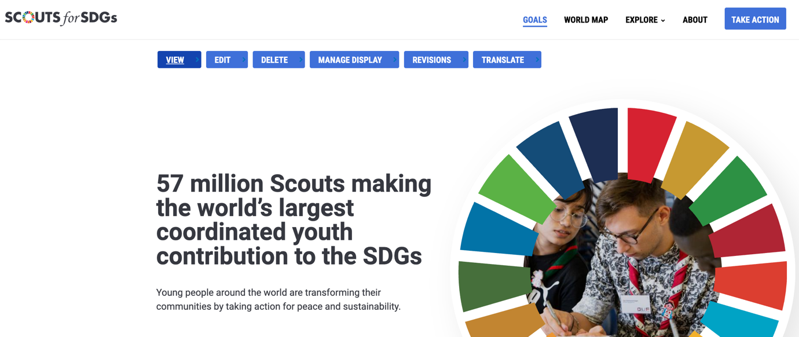

5. TECHNICAL INFORMATION FOR NATIONAL OPERATORS

5.1 Reporting, evaluation and future
WOSM will be required to submit a report two times a year.
- 1st report (Deadline – May 30 2023) - final report NH and mid-term SH. Reports from countries shall be shared with WOSM on May 15, 2023.
- 2nd report (Deadline – November 30, 2023) - mid-term NH and final report SH. Reports from countries shall be shared with WOSM on November 15, 2023.
As a scouts leader, you are expected to provide the WOSM with the following information (based on the agreement between you and WOSM):
- Number of scouts in your group participating in the campaign
- Number of presentations done by your scouts
- The city where your group is located
- Number of entries submitted for the national competition by your group

6. WEBSITE AND SOCIAL MEDIA

6.1 Planned external communication/media outreach related to this grant and program
A media campaign will be organised nationally (by the YRE National Operator) and internationally (by the FEE Head Office) to promote mass awareness for the campaign. Detailed activities will be planned together with PR and communication experts through a media/PR company or individually by the YRE National Operator.
As a scout group leader, you are expected to share news of your Litter Less Campaign related activities in your media outlets. When presenting news on social media, remember to always use the hashtag #Litterlesscampaign and for this year #litterlessplus. This is so we can track posts specific to the campaign and be able to assess the global reach. Below are also some other general hashtags and keywords that you can add for extra exposure.
You can also connect with WOSM social media channels in Instagram, Facebook and TikTok by adding
You can
General # | General keywords
#Scouts4SDGs  #litterless  #litterlesscampaign  #litterlessplus  #YRE  #LLC  #youngreportersfortheenvironment  #YRELLC  #YRELitterless  #youngreporters  #yrellccompetition  #communityactiondays  #Scouts  #WoldScouting  #BetterWorld | Scouts for SDGs  Litter Less Campaign  Litter  Litter Less Plus  Litterless  community action days  Young Reporters for the Environment (YRE)  Mars Wrigley Foundation  YRE International Competition  YRE programme  WOSM Initiatives  Earth Tribe Initiative

6.2 Reporting from Scouts International Coordinator at WOSM
The online communication platform Podio is for the management of member organisations participating in the LLC. Additional documents, educational and other materials can be found here.
The online platform Podio is an important tool for all our project to be familiar with. On Podio, different so-called “Workspaces” can be created. As a LLC partner, you will be invited to the workspace “#Scouts, ASPnet Litter Less Campaign”.
First you need to sign up yourself to Podio with the email you will be using there. Citrix Podio. Let us know the email and we will invite you to the workspace in Podio.

6.3 Litter Less logo
The Litter Less Campaign is labelled by its logo which should be presented on materials produced during the campaign. The logo can be found on Podio (YRE Litter Less Phase V) in the Files Library.
For activities and materials associated with the Litter Less Plus Campaign during 2023, please use the Litter Less Plus logo.
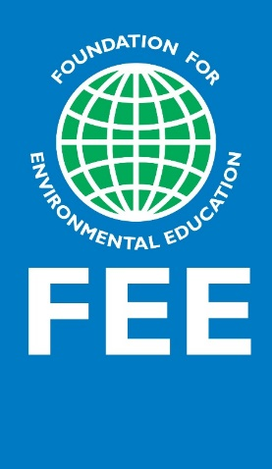

Structure of use and logos presentation
  - LLC logo and the Earth Tribe logo shall be presented at any time when the campaign is mentioned.
  - The FEE logo shall be placed on the WOSM and the National Scouts pages and used at the presentation of the campaign.
  - FEE members that are coordinating the YRE programme shall be presented at each country accordingly and the logo shall be used in presentations, websites and other communication channels on the national level that avoid confusion on how the e.g. competition entries will be submitted for the competition and who is coordinating it.

6.4 Earth Tribe Initiative Logo
If your NSO is incorporating LLC and YRE as part of your Earth Tribe initiative, please use the Earth Tribe logo to indicate the connection. You can reach out to the Regional Support Centre of your region for additional guidance.
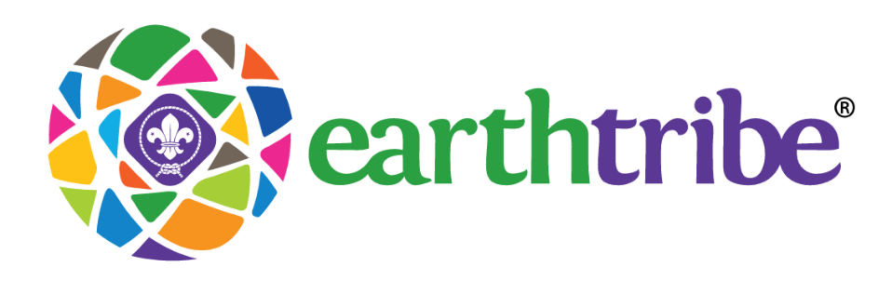

7. Annexes

Annex 1: Additional information Young Reporters for the Environment
Young Reporters for the Environment (YRE) is a network of international youth engaged in education for sustainable development, coordinated by the Foundation for Environmental Education (FEE). The goal of YRE is to engage youth in resolving environmental issues.
Young Reporters, aged between 11 and 25 in more than 43 countries, investigate environmental problems and issues and propose solutions through published investigative reporting, photographic and video journalism. YRE also enables participants to develop skills and expand their knowledge. For instance, as well as gaining a deeper understanding of sustainable development, the programme teaches or enhances communication and citizenship skills, individual initiative, teamwork, critical analysis, social responsibility and leadership. Each student or group is supported by the national organisation (National Operator) running YRE, who in turn receives support and guidance from FEE. An international YRE website, as well as social media platforms, are also set up to provide information, inspiration and ways to connect.
Every year, the best article (written in English), photograph and video in each age category are submitted to the international competition, following a national one, where they are assessed by an international YRE jury. The jury is made up of expert representatives from the FEE Executive Board, organisations and agencies e.g. UNEP, UNESCO and the European Environment Agency (EEA), as well as the media. Certificates or prizes are awarded to the best article, photograph and video in each of the three age categories, and international workshops may also take place.
The international network created by youth in participating countries serves as a press agency, specialising in producing and delivering environmental news. In the context of the Litter Less Campaign, the YRE network acts as the driving force to report on litter throughout the campaign.
Annex 2: Overview YRE National Operators
You can find a list of all YRE National Operators here.

Annex 3: Participating numbers for 2022
Programme outreach in total (from Year 1):
- Number of individuals reached by media: 1,454,635
- Number of individuals trained as educators or leaders 19,117 (it includes training organised in countries, webinars and FEE Academy)
- Total number of individuals reached* - 290,442
- Percent change in behaviour and understanding – this data will be available after the NH will complete their implementation
- Number of schools implementing the program - 3054
- Number of cities reached by the project/program – approx. 113

Annex 4: Campaign implementation cases from previous years

Stories from Countries — Young Reporters for the Environment (yre.global)

Annex 5: Four YRE steps to implement the campaign
- Investigation
The students will identify where they would investigate local litter and waste issues.
- Identify, define and communicate a local problem and/or issue related to litter.
- Investigate (look up, compare, interpret, evaluate) relevant information from primary and secondary sources.
- Identify key individuals/local stakeholders and groups and find out what their different perspectives on the issue are their approaches to resolving it and their assumptions and goals.
- Conduct original research, such as surveys/questionnaires, and interview key individuals or groups to obtain first-hand information.
- Cover relevant historical, economic, social and/or political implications and possible consequences of the issue.
- Link the local litter problem to the bigger global picture (problem).
- Proposing solutions
Propose solutions to a local issue related to litter:
- Identify a possible solution to the litter issue and evaluate its likely effectiveness, giving reasons for and against (pros and cons).
- Do not propose solutions on your own. Use local stakeholders or/and international sources to get knowledge and recommendations.
- Reporting
Report on a local litter issue and its possible solution through a journalistic production targeting a local audience:
- Identify your target audience and choose the best way to reach and communicate with them, i.e. which media do they read/watch/listen to?
- Plan how you will report on the issue (who needs to be informed? how? when?) and use the appropriate journalistic format and style.
- Create an article, photo, or video that documents the litter issue; where possible you should suggest a solution.
- Take a positive approach to inspiring change and finding a solution to the litter problem.
- Informing
Share (disseminate) your work to a local audience through the media, e.g. newspaper, magazine, radio, television, social media, exhibition, film show, local events, etc. To do so, get in touch with local TV or radio channels.

